

### Matthew Castleberry, Josh JABLONOWSKI, JOE hinley, nia perkins

IEEE Southeastcon hardware competition

## Spring 2019 Senior Design

Senior Design Project Notebook

##### [Click here to enter a date]

|  |  |
| --- | --- |
|  | IEEE SOUTHEASTCON Senior Design Notebook­ |

|  |  |
| --- | --- |
|  | IEEE SOUTHEASTCON Senior Design Notebook |

|  |  |
| --- | --- |
|  | IEEE SOUTHEASTCON Senior Design Notebook |

|  |  |
| --- | --- |
|  | IEEE SOUTHEASTCON Senior Design Notebook |

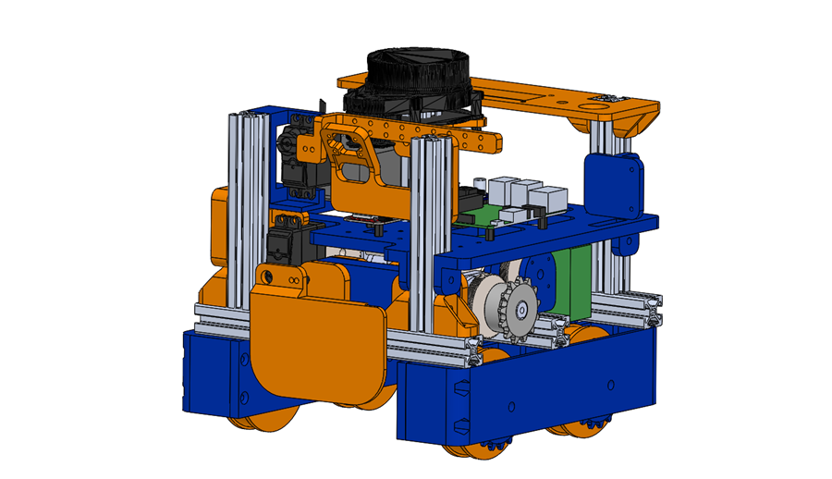

IN THIS SECTION:

* Project overview

## Overview

**Tab 1**

Senior Design Project Notebook



IN THIS SECTION:

* Project Proposal
* Mid Semester Report
* Final Report
* Meeting Notes and Weekly Reports

## Presentations and Reports

**Tab 2**

Senior Design Project Notebook



IN THIS SECTION:

* Mechanical Hardware
* Electrical Hardware
* Software

## Technical Documentation

**Tab 3**

Senior Design Project Notebook

**Tab 4**



IN THIS SECTION:

* Overview
* Logistic Notes
* What We Learned
* Future Work

## Competition Details

Senior Design Project Notebook



IN THIS SECTION:

* Budget
* Purchase Orders

## Administrative Documentation

Senior Design Project Notebook

**Tab 5**



IN THIS SECTION:

* Appendix A: Datasheets
* Appendix B: Source Code

## Appendices

Senior Design Project Notebook

**Tab 6**